SpectraOps Ltd. – Organizational Hierarichal Structure

Executive Leadership
- Chief Executive Officer (CEO) – Zohaib Ahmad Tariq
Defines the company’s vision, business strategy, and key goals.
- Chief Operating Officer (COO) – Ali Haider
Manages company-wide operations, ensuring efficiency.
- Chief Financial Officer (CFO) – Abdullah
Handles budgeting, financial planning, and investment decisions.
- Chief Technology Officer (CTO) – Rana Talha Majid
Leads R&D, product development, and cybersecurity innovations.
- Chief Information Security Officer (CISO) – Jamshed Fareed
Manages cybersecurity risks, policies and compliance.
- Chief Marketing Officer (CMO) – Rao Asad
Develops marketing, branding, and sponsorship strategies.
- Country Head – Muhammad Ammar
Represents and manages company operations within the country.

Website Management Department
- Senior Management:
- Vice President of web and IT services – Rana Talha Majid
Leads website infrastructure, IT systems, and digital services.
- Middle Management:
- SEO and Digital content manager – Ali Haider
Manages search engine optimization and website analytics.
- Web development manager – Talha Majid
Builds and maintains the website’s functionality and features.

Cyber Security Department
- President - Jamshed Fareed
Heads cybersecurity strategy, governance, and major initiatives.
- Vice President of Cyber Security Services – Ali Haider
Oversees cybersecurity programs and client-facing services.
- Vice President of Risk and Compliance – Zohaib Ahmad Tariq
Manages legal, regulatory, and internal compliance risks.
Supports operational leadership and team coordination.
- Security operations center (SOC) – Eman Fatima
Leads the team monitoring and responding to security incidents.
- Director of Penetration Testing and Red Teaming
Conducts simulated cyberattacks to identify vulnerabilities.
- Incident Report Manager – Awais Qureshi
Oversees security breach investigations and response plans.
- Cyber Security Consulting Manager
Handles client security assessments and advisory services.
- Threat Intelligence Manager
Leads research on new cyber threats and vulnerabilities.

Marketing and Sponsorship Department
- Senior Management:
- Vice President of Marketing and Sponsorships
Leads brand partnerships, promotions, and marketing planning.
- Middle Management:
- Director of Digital Marketing – Ashar Sheroz
Manages all online campaigns, advertising, and analytics.
- Sponsorship and Partnerships Manager
Develops Relationships.
- Social Media Manager – Eman Fatima
Oversees all social media channels and content creation.

Risk Management Department:
- Auditor – Muhammad Ammar
Performs audits to evaluate internal controls and processes.
- Policy and Governance Specialist
Develops and monitors policy frameworks and governance standards.
- Legal and Data privacy officer
Ensures legal compliance and protects user data privacy.

Human Resource Department:
- Talha Majid
- Zohaib ahmad
- Awais Qureshi

Artificial Intelligence Division
- Hafiz Rao Asad – Ur – Rehman
- Bilal Ahmad

Visuals / Design Department
- Hamza Rajput
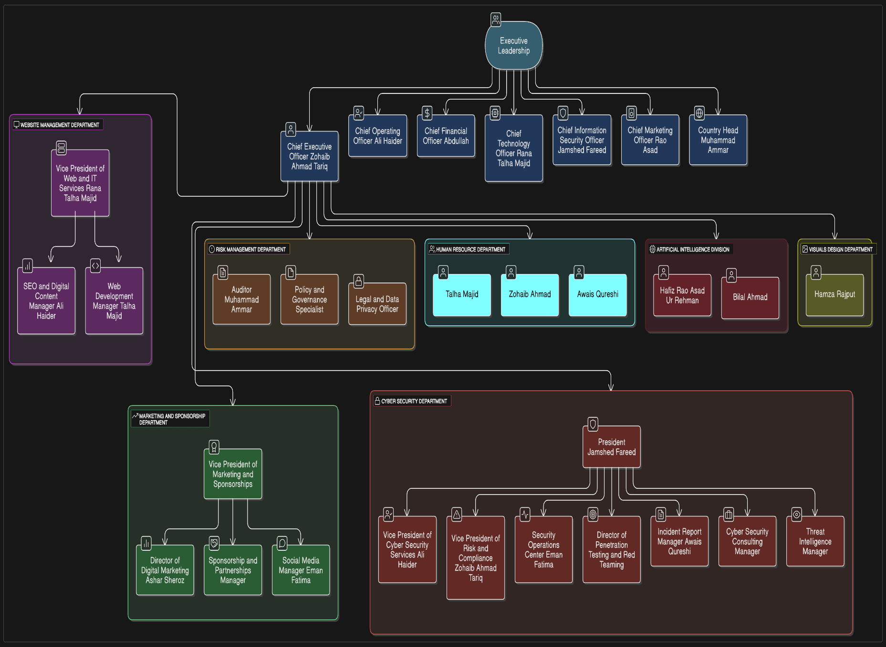

SpectraOps Ltd. – Role-Level Sorting (Seniority-Based)

Executive Leadership
Top-level strategic leadership of the organization.
- CEO – Zohaib Ahmad Tariq
- COO – Ali Haider
- CFO – Abdullah
- CTO – Rana Talha Majid
- CISO – Jamshed Fareed
- CMO – Rao Asad
- Country Head – Muhammad Ammar

Senior Management
Oversees entire departments and major company functions.
- President (Cyber Security ) – Jamshed Fareed
- Vice President of Web and IT Services – Rana Talha Majid
- Vice President of Cybersecurity Services – Ali Haider
- Vice President of Risk and Compliance – Zohaib Ahmad Tariq
- Vice President of Marketing and Sponsorships –
- Vice President (Cybersecurity) – Zeeshan

Middle Management
Operational and functional leadership within departments.

Website Management Department
- SEO and Digital Content Manager – Ali Haider
- Web Development Manager – Talha Majid

Cyber Security Department
- Security Operations Center – Eman Fatima
- Director of Penetration Testing and Red Teaming
- Incident Report Manager – Awais Qureshi
- Cybersecurity Consulting Manager
- Threat Intelligence Manager

Marketing and Sponsorship
- Director of Digital Marketing – Ashar Sheroz
- Sponsorship and Partnerships Manager
- Social Media Manager – Eman Fatima

Specialists / Analysts / Support Roles
These roles focus on execution and subject-matter expertise.

Risk Management
- Auditor – Muhammad Ammar
- Policy and Governance Specialist
- Legal and Data Privacy Officer

AI Division
- Hafiz Rao Asad–Ur–Rehman
- Bilal Ahmad

Visual Design
- Hamza Rajput

Shared / Cross-Functional Roles
Part of multiple operational processes; supportive or administrative.

Human Resource Department
- Talha Majid
- Zohaib Ahmad
- Awais Qureshi

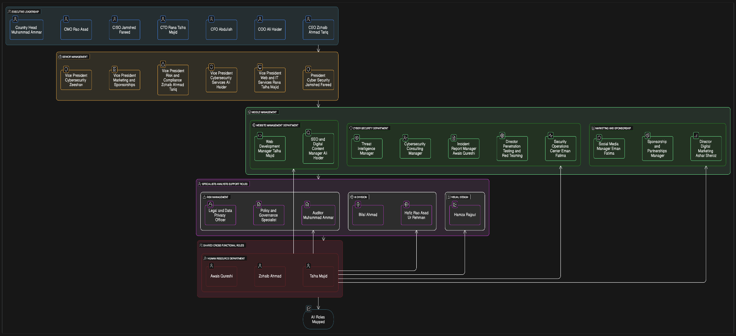

SpectraOPs Ltd. – Departmental Sorting

Website Management Department
- Vice President of Web and IT services: Rana Talha Majid
- SEO and Digital Content Manager – Ali Haider
- Web development Manager – Talha Majid

Cyber Security Services Department
- President: Jamshed Fareed
- Vice President of Cyber Security Services: Ali Haider
- Vice President of Risk and Compliance: Zohaib Ahmad Tariq
- Vice President: Zeeshan
- Security Operations Center (SOC): Eman
- Director of Penetration Testing and Red Teaming
- Incident Report Manager: Awais Qureshi
- Cyber Security Consulting Manager
- Threat Intelligence Manager

Marketing and Sponsorships department
- Vice President of Marketing and Sponsorships
- Director of digital marketing: Ashar Sheroz
- Sponsorship and Partnership Manager
- Social media Manager: Eman Fatima

Risk Management Department
- Auditor: Muhammad Ammar
- Policy and Governance Specialist
- Legal and Data Privacy

Human Resource Department
- Talha Majid
- Zohaib Ahmad
- Awais Qureshi

Artificial Intelligence division
- Hafiz Rao Asad-ur-Rehman
- Bilal Ahmad

Visuals / Design Department
- Hamza Rajput
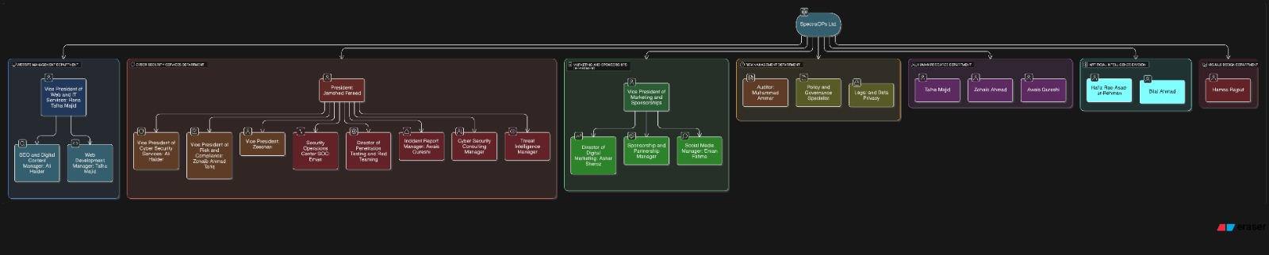

People to add:

SpectraOps Ltd.

Short Film ref:
- Hamza Rajput
- Talha Aslam
- Mohd Kasim

Lead Cyber Team:
- Zohaib Tariq
- Ali Haider
- Jamshaid Fareed
- Muhammad Talha
- Muhammad Zaid
- Faizan Ikram
- Muhammad Maaz
- Awais Qureshi
- Muhammad Farhan
- Faheem Baloch
- Mehdi ul Hassan
- Abu Bakr

CS Department:
- Abdullah Jameel
- Muhammad Ammar
- Ali Asad
- Hassan Arif
- Fahad Kasim
- Bilal Ahmad

AI and Robotics:
- Rao Asad

Marketing and Sponsorship:
- Talha Aslam

Web Management:
- Talha Majid

Office Management:
- Muiz Mughal

Receptionist:
- Shafaq Zia

